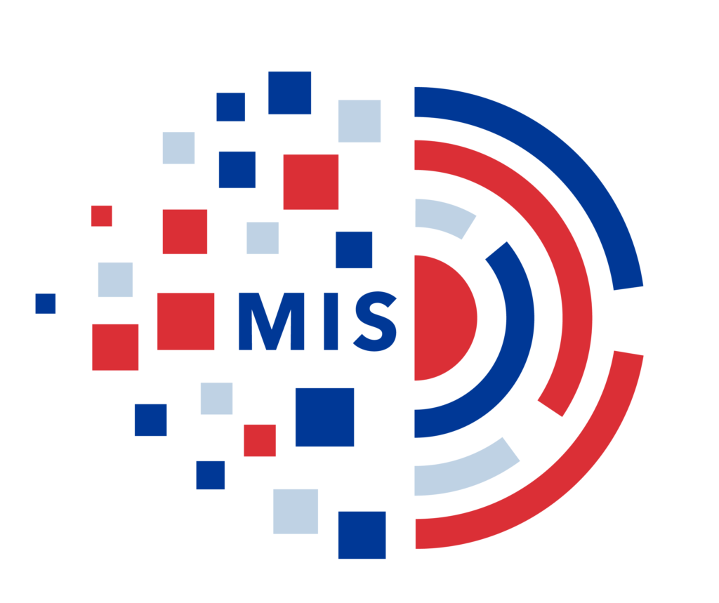

|  |
| --- |
| **Management**  **Information**  **System** |

|  |  |
| --- | --- |
| **Asst. Professor Mr. Yogesh Joshi**  **Faculty of Commerce & Business Management**  **Amrapali University** |  |

**MAU 06(Management Information System)**

Hello, students. Welcome to the new course on **Management Information Systems**. Let me begin by introducing myself. My name is Mr. Yogesh Joshi. I hold a postgraduate degree (M.C.A) from the Amrapali Group of Institutes, affiliated with Uttarakhand Technical University. I have a total of 7 years of experience, including 5 years in the industry and 2 years in teaching. I worked at “**Kirloskar Oil & Engines Limited**” from December 2017 to August 2021, followed by a teaching position at “**Apex Institute of Technology**” from September 2021 to June 2023. Currently, I am with Amrapali University, where I have been working since July 2023.

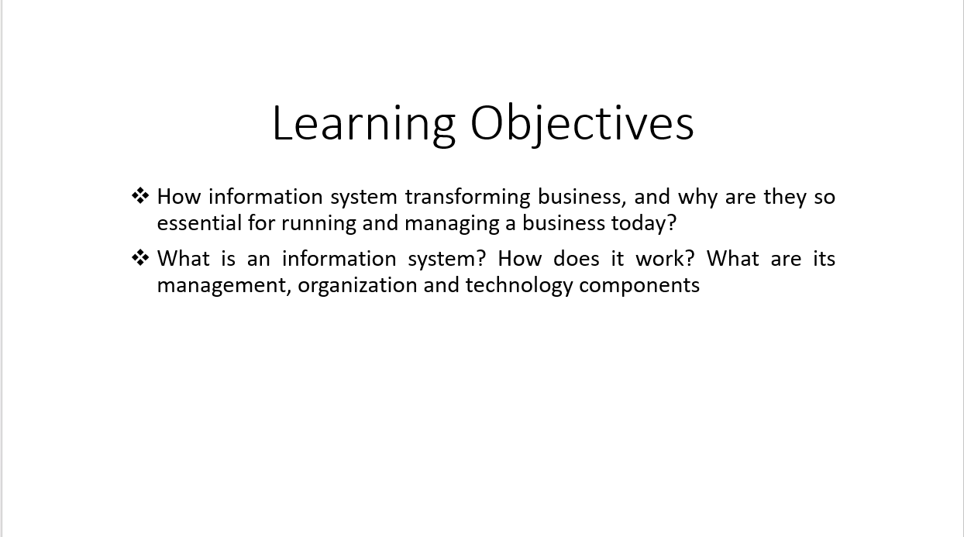

Management information system is a broad area of subject which covers really the various areas required to run a modern business and all of you know that it is all information driven. we are all talking about data and **data leads to information**. Without data we are actually very helpless, like without electricity we are helpless; data is something very similar in today’s cyber world data you can say is somewhat equivalent to electricity in the real (core) world. In the Core sector what is “Electricity” in the cyber world, or in the digital world it is “Data”. That's why you'll often hear a lot of emphasis on data everywhere—it's all about data, which eventually turns into information. The focus of Management Information Systems (MIS) is on managing this data and converting it into valuable information, knowledge, and ultimately, wisdom. With this in mind, the learning objectives of this course are set. We'll explore how information systems are transforming businesses and why they are now essential for effectively running and managing a business in today's world. The core focus here is on running a business. However, it's important to note that data plays a crucial role in many fields, including education. For instance, in the field of education, schools and universities generate large volumes of data daily. We see important data and information being shared in reports and academic journals, such as student enrolment numbers, exam results, and trends in online learning.

So, it's about gathering data and then converting it into graphs to make predictions. And why do we use graphs? Because we need to forecast and predict what might happen in the future—whether it's a week from now, two weeks, three weeks, or next month. For example, in the retail industry, businesses analyse sales data to predict future trends. They use graphs to forecast demand for certain products, helping them make informed decisions about inventory and marketing strategies.

**Decision-makers rely on this information to plan effectively**. The core of Management Information Systems is about providing valuable insights that help decision-makers make informed choices and organize their activities. This is why understanding the concept of planning is crucial for management students. After all, a manager's role often revolves around planning, ensuring they are prepared to handle various situations efficiently.

**A manager's primary responsibility is to handle any situation**—whether it involves managing tasks, the workforce, or resources. Effective management of these aspects is essential for any business, and this begins with planning. Planning is the foundation of all managerial activities, and to plan effectively, you need accurate information. Without information, you can't make informed decisions, leaving you without direction or clarity.

So, what is an information system? To understand this, we need to break it down. **An information system includes three main parts: management, organization, and technology**. These parts work together to form a complete system. It’s not just about digital tools; it also involves physical hardware. We’ll look at both these aspects in detail. We’ll also discuss additional resources needed to make sure the system provides value to the organization. As a manager, knowing how these systems work and how they benefit the business is crucial for making effective decisions.

**Goal of MIS:**

**(Goals of MIS)**

We’ve talked about how it starts with data, then it leads to information. You need information from data. This is the starting point of MIS. From data and information, you finally, generate knowledge by which you become knowledgeable and the last stage is of course, the highest one, which is “wisdom”

We focus on the first three levels—**data, information, and knowledge**—for daily management needs. Let's take the current debate on **artificial intelligence (AI) in the workplace as an example.**

Data on AI usage shows various statistics about its impact on productivity, job creation, and job displacement. This data turns into information when it's analysed and presented in reports, indicating trends such as increased efficiency or the potential for job losses in certain sectors.

From this information, knowledge is generated. For instance, experts and organizations might have differing views on how AI should be integrated into workplaces. Some believe AI enhances productivity and creates new job opportunities, while others worry about job displacement and ethical concerns.

This debate illustrates the knowledge level, where various opinions and studies present different perspectives. The ultimate goal is to reach a level of wisdom—where a consensus or well-informed strategy is established. For example, companies might adopt hybrid approaches that leverage AI's benefits while addressing ethical concerns and supporting workers affected by AI-driven changes.

In summary, understanding how data transforms into information and then into knowledge helps managers make better decisions. Reaching a level of wisdom involves synthesizing these insights into effective strategies, ensuring that all perspectives are considered, and making decisions that balance benefits and challenges.

Let’s use another example of planning a school event:

1. **Data Collection**: You gather basic data like the number of students attending, the types of food they like, and their availability on different dates.
2. **Information Generation**: By analysing this data, you can create information, such as a chart showing which food items are most popular and the best dates when most students are available.
3. **Knowledge Formation**: From this information, you understand the preferences and availability patterns. For example, you learn that students prefer pizza and that a Friday evening is the most convenient time for the majority.
4. **Wisdom Application**: Using this knowledge, you make the decision to plan the event for Friday evening and arrange for pizza as the main food. This decision is based on a clear understanding of the students' preferences and availability.

In summary, you start with data, turn it into useful information, develop knowledge about preferences and patterns, and finally make a well-informed decision that ensures the event will be successful.

**What is an information system?**

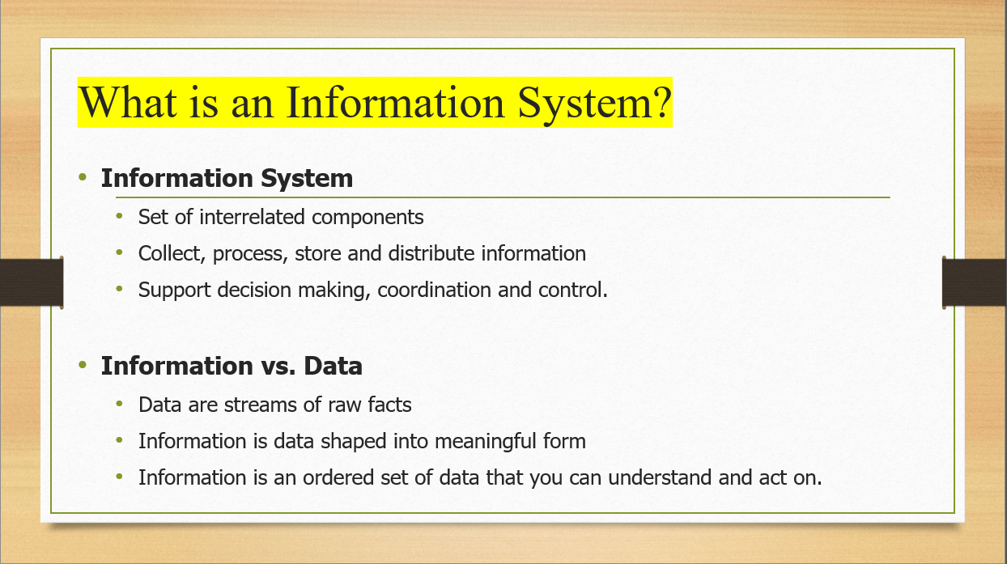

**Information system** is set of inter related components. It collects, processes, stores and distributes information. It supports decision making, coordination and control. We have already talked about little bit that how it helps in decision making, because that is what we are doing every day; we are taking decisions right? To make good decisions, we need to understand the potential outcomes: if I take this action, this could happen; if I don't, I might miss out. We constantly do this kind of "**what-if**" analysis in our daily lives. It's not just for business; we do it at home too. For example, as a family leader, you make many decisions about things like your children's schooling and other daily matters.

Let’s differentiate between **data and information**. Data consists of raw facts, like daily measurements of your body temperature: today it’s 98 degrees, tomorrow it’s 97.8, and the next day it’s 99. Each of these is just a piece of data.

Information, on the other hand, is what you get when data is organized into a meaningful form. For instance, if your temperature is 98 degrees, the information is that you’re likely healthy. But if your temperature rises to 99 degrees, the information indicates that you might be unwell and should consider seeing a doctor or taking some medicine.

***Information is essentially an organized set of data that helps you make decisions and take actions.***

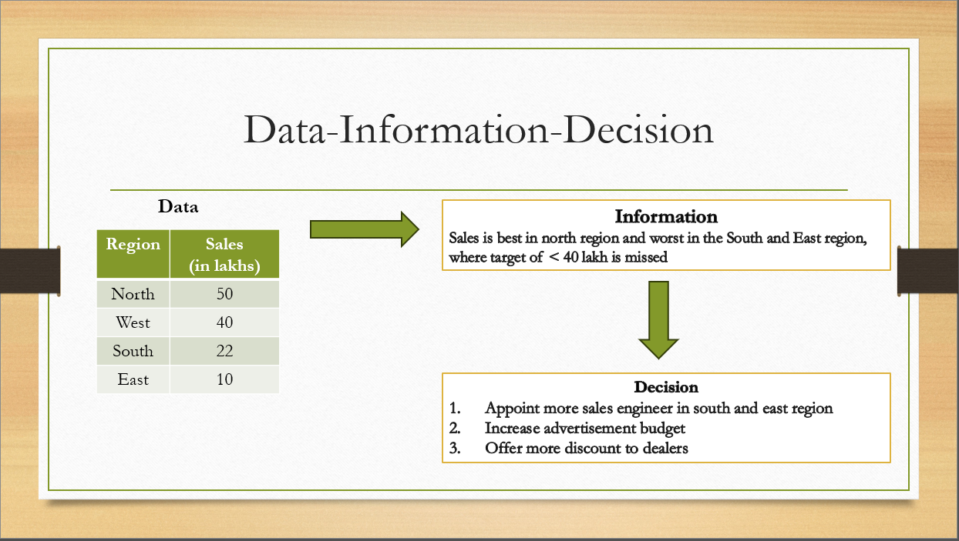

Now, you understand we start with a data, we generate a information and then as a manager we take a decision.

Three activities of information systems produce information organization needs. The three activities are: **input** which captures the raw data from organization and external environment, **processing** converts the raw data into meaningful form and **output** is the transferred process information to people.

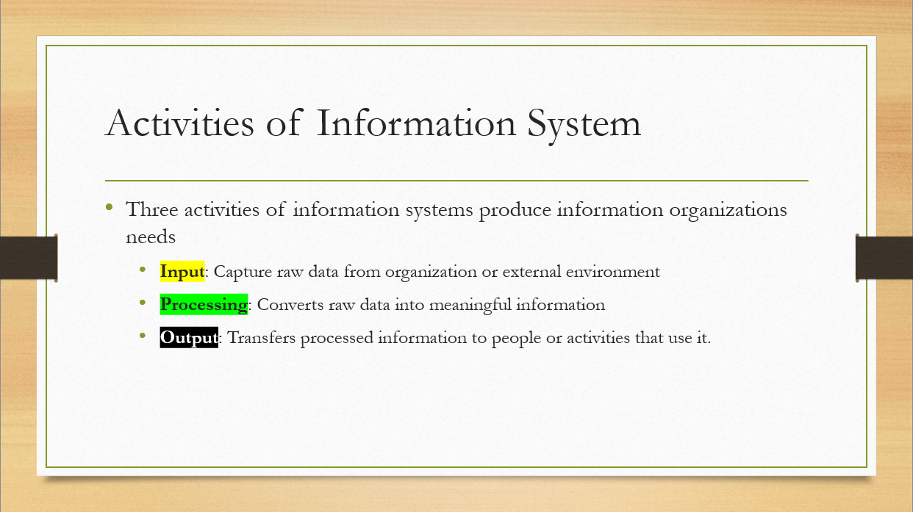

Now, the processing part can be manual in many cases like the previous examples we discussed. And, we saw the data and we could process and we could find out what is the information. But, in many cases when there are lots of data and etc. then you need computers to do the processing for you and it comes out with a report. And, in the report you will get all the information that is based from this data.

So, all that is an output from a computer, but it is nothing, but a report. So, that is the output. So, there are three things: Input, Processing, Output.

**Feedback** is crucial for refining processes within an organization. When you receive output, it might reveal issues such as incorrect data, flawed analysis, or errors in the formula used. Feedback helps identify these problems and allows you to adjust the input or processing to correct the errors and achieve the desired outcome. It ensures that the final output is accurate and reliable.

Now, regarding computers and information systems: Think of computers and software as the basic tools and materials needed to build a house, like bricks and cement. While these are essential, they alone don’t make a complete information system. Just as you need to actually construct and furnish the house for it to be usable, computers and software must be integrated into a complete system that includes processes and user interactions. Only then does it function effectively as an information system.

**How information systems are transforming business?**

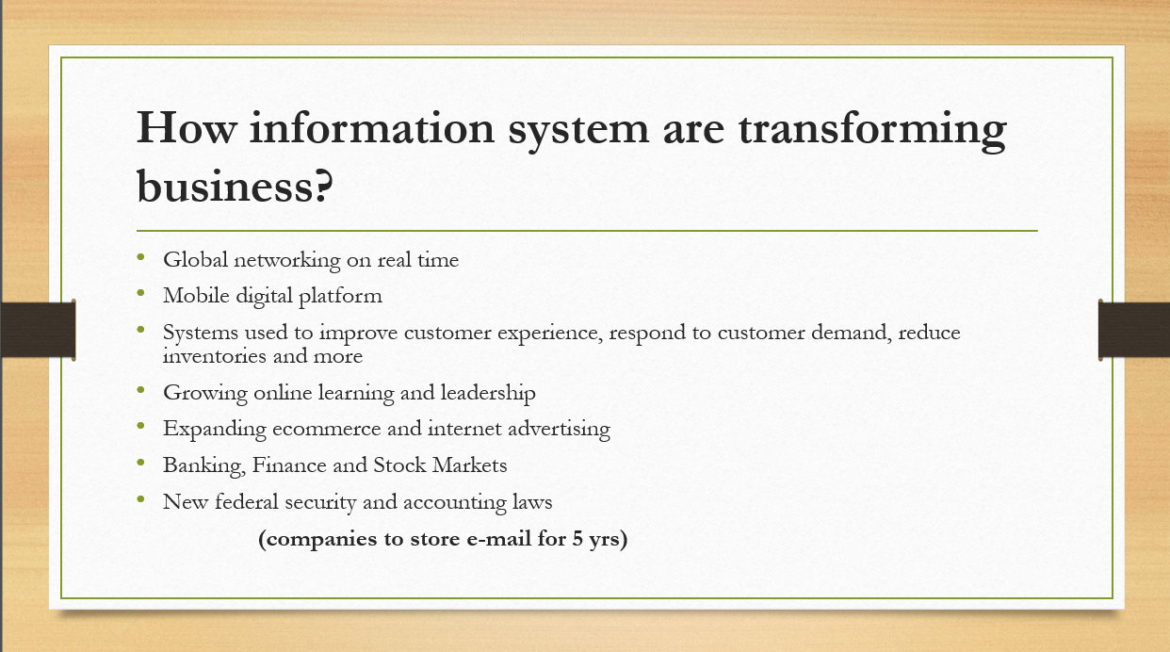

Information systems are crucial for transforming businesses. This means they help businesses operate more effectively, grow, modernize, and adapt to changes. In today’s fast-paced world, businesses must continuously evolve. Information systems provide essential updates, such as product performance data, market trends, and competitive threats. With this information, businesses can make informed decisions and adjust their strategies to stay competitive and successful. Information systems are vital because they provide the information needed to run a business effectively. Without this information, you’d be like an island, isolated and unable to make informed decisions. For example, without data on sales and market trends, you might find yourself unexpectedly facing declining sales and business challenges. Information systems help you monitor your operations, understand market conditions, and make adjustments, ensuring that your business stays on track and avoids potential problems.

**Information systems** are crucial across all sectors, including finance, banking, manufacturing, digital platforms, networking, and government departments. For example, statistical departments collect extensive data through censuses, covering aspects like population, health, and education. This data informs critical government decisions, such as allocating funds to healthcare or education.

In essence, managing information systems is vital in every field—whether it's government, private industry, healthcare, banking, or sports. It's all about using information effectively to make informed decisions and drive progress.

**What is new in management information system?**

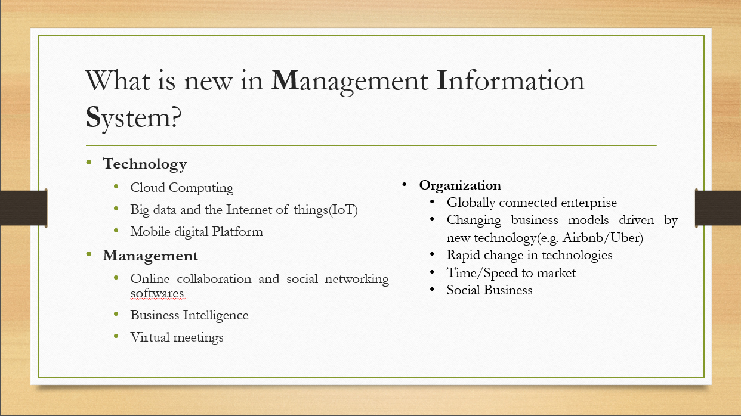

**Technology** is evolving rapidly, and what was current just a few years ago can quickly become outdated. Today, terms like cloud computing, big data, the Internet of Things (IoT), and mobile digital platforms are at the forefront. These technologies are crucial for managing information systems.

From a **management** perspective, new trends such as online collaboration tools and social networking software are becoming increasingly important. Social media platforms like Facebook play a significant role in business and advertising today. Unlike traditional print media, which requires physical materials and logistics, digital advertising can quickly reach a global audience without the need for physical distribution.

For example, a video posted online from Kolkata can become viral and be viewed almost instantaneously by people in New York, London, Tokyo, and beyond. This viral spread of content illustrates the power and reach of digital media in today’s interconnected world.

Business intelligence (BI) is a sophisticated tool used to extract valuable insights from basic data. Essentially, BI tools help you analyse and interpret data more intelligently by providing detailed and varied reports. This allows businesses to make informed decisions based on a deeper understanding of their data.

Another significant change in recent times is the rise of virtual meetings. Post-COVID-19, virtual meetings have become essential. For example, instead of traveling to Delhi, chief ministers now attend meetings with the Prime Minister via video conference. This shift has extended to various sectors, including government and business, where virtual meetings have largely replaced in-person meetings.

As of early July 2020, the rapid adoption of virtual meetings over the past few months has transformed how we manage communications and collaborations. The ability to hold effective meetings from different locations has become a new standard.

**Organizations** today are more globally connected than ever, thanks to globalization. This means that businesses based in one country can interact with and operate in countries all around the world in real-time. For example, a company headquartered in the US can have operations and communications with partners and customers across the globe instantly.

Recent technological advancements have also led to new business models. Take Uber and Airbnb, for instance. Uber, a popular taxi service, doesn't own any cars. Instead, it connects drivers with passengers through its app. Similarly, Airbnb operates as a platform where people can rent out their homes or rooms to guests without owning any hotels. These models have emerged in the last few years and have disrupted traditional industries, creating new challenges for established companies.

The rapid pace of technological change, such as developments in cloud computing and the Internet of Things (IoT), continues to impact how information systems are managed. Companies must adapt quickly to stay competitive.

Speed to market is also crucial. For example, in the race to develop a COVID-19 vaccine, companies that bring a vaccine to market first will gain a significant advantage. This illustrates how information systems help accelerate product development and market entry.

Lastly, there's a growing focus on social business, which aims to address societal issues while still being sustainable. For example, in India, there are efforts to improve education levels, particularly in underserved areas. Social businesses prioritize societal benefits alongside or even above profit, contributing to overall social development.

**Thank you very much.**

***************************************************************************